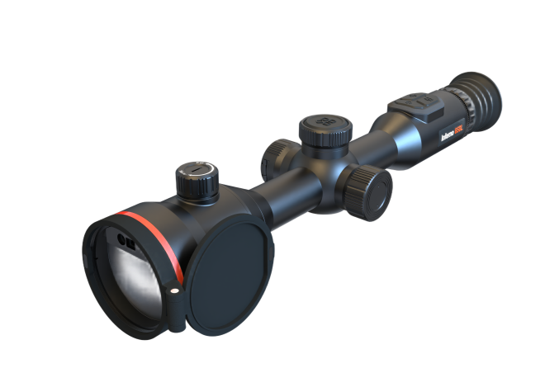

COUG CG335L

Thermal Scope

Inferno 335L features a 384×288 @12μm VOx detector with NETD ≤18 mK and 50Hz frame rate, delivering clear imaging in all conditions. Equipped with a 35mm F0.9 lens, it achieves a detection range of up to 1800m. The built-in 905nm Class 1 laser rangefinder and ballistic calculation ensure accurate shooting. Adopting dual batteries, it supports up to 17 hours of continuous use. With IP67 rating and 1000g shock resistance, it performs reliably with high-caliber firearms in harsh outdoor environments.

Key Features
- 384 × 288 @12 μm VOx thermal detector, NETD ≤18 mK, 50Hz frame rate
- 35mm F0.9 lens, max detection range up to 1800m
- 0.39-inch AMOLED display with 1024×768 resolution, multiple scene modes & color palettes
- 905nm Class 1 laser rangefinder (1.2km, ±1m accuracy) + ballistic calculation & calibration
- Dual battery design, continuous working time ≥17h at 25°C, battery non-polar design for normal operation in forward and reverse installation
- 10 zeroing profiles, rich reticle and aim point options
- IP67 protection, operating temperature: -20°C ~ +50°C, shock resistance up to 1000g/0.4ms
- Wi-Fi connection, 64GB storage, video recording, snapshot and electronic compass supported

n Specification
Thermal Module
Image Sensor | UFPA (VOx)
Resolution | 384×288
Pixel Pitch | 12µm
Frame Rate | 50Hz
NETD | ≤18mk
Spectral Range | 8-14µm
Optical Parameter
Focal length / Aperture | 35mm; F0.9
Field of View | 7.5°×5.6°
Base Magnification | 3.4X
Focusing Mode | Focus Knob
Eye Relief | 40mm
Exit Pupil | / 6mm
Diopter | +5D to -5D
Detection Range | 1800m (Human; 3pixels)
Recognition Range | 450m (Human; 12pixels)
Image Display
Screen | AMOLED, 0.39 inch
Resolution | 1024×768
Screen Brightness Adjustment | Support
Brightness Adjustment | Support
Contrast Adjustment | Support
Image Enhancement | Support
Scene Mode | City;Plain;Forest
Display Mode | Circle;Box
Color Palette | White Hot/Black Hot/Red Hot/Fusion/Golden Hot etc.
Digital Zoom | 1× to 4× step by 0.2×
Power Supply
Battery type & Number | 1 built-in 21700 Lithium battery & 1 replaceable 18650 Lithium battery
External Power Supply | DC 5V (USB Type-C)
Battery Operating Time | ≥17h （25℃）
System
Record Video | Support
Capture Snapshot | Support
Audio Recording | Support
Local Album | Support
Recoil Activation Recording | Support
Picture in Picture | Support
Hot Track | Support
Zeroing Adaptation Mode | Support
Screen Adaptation | -
Standby Mode | Support
Ballistic Calculation | Support
Ballistic Calibration | Support
Distance Measurement | Support
Zeroing Profiles | 10
Reticle Pattern | 8
Reticle Pattern | 6
Aim Point Type | 3
Aim Point Colour | 6
BC Aim Point Type | 5
BC Aim Point Colour | 4
Ranging Cursor Type | 3
Ranging Cursor Colour | 3
Peripheral
Electronic Compass | Support
Attitude Sensor | Support
WIFI /APP | Support; 2.4G
Storage | Built-in EMMC (64GB)
Laser Rangefinder | 905nm;Class 1 Laser Safety
Ranging Distance & Accuracy | 1.2 Km*; ±1m
General
Data Transmission Interface | USB (Type-C)
Protection Level | IP67
Operating Temperature | -20°C to +50°C
Max. Recoil | 1000g/0.4ms
Weight（without battery） | ≤935g
Dimension | 383×90×86（mm）

